HEALTHCARE DIAGNOSIS SUPPORT
A Project Report Submitted in the partial fulfillment of the requirements for the award of the degree of

BACHELOR OF TECHNOLOGY
In
DEPARTMENT OF COMPUTER SCIENCE ENGINEERING

By
N. VEDA SAMHITA- 2420030468
M. SRIHITHA – 2420030405
T. DHANYA SRI- 2420030338
Under the Esteemed Guidance of

VENKATESWARI KETINENI

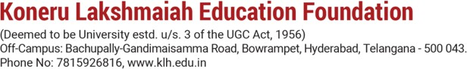

K L (Deemed to be) University

DEPARTMENT OF COMPUTER SCIENCE ENGINEERING


Declaration

The Project Report entitled “Healthcare Diagnosis Support” is a record of Bonafide work of team members N. Veda Samhita – 2420030468, M. Srihitha – 2420030405, T. Dhanya Sri - 2420030338 submitted in partial fulfilment for the award of B. Tech in Computer Engineering to K L University. The results embodied in this report have not been copied from any other departments/University/Institute.

N. Veda Samhita - 2420030468
M. Srihitha – 2420030405
T. Dhanya Sri - 2420030338

K L (Deemed to be) University DEPARTMENT OF COMPUTER SCIENCE ENGINEERING


Certificate

This is to certify that the project-based report entitled “Healthcare Diagnosis Support” is a Bonafide work carried out and submitted by N. Veda Samhita – 2420030468, M. Srihitha – 2420030405, T. Dhanya Sri - 2420030338, in partial fulfilment of the requirements for the award of the degree of Bachelor of Technology in Computer Science Engineering, at K L (Deemed to be University), during the academic year 2025–2026.

Signature of the Supervisor

Signature of the HOD Signature of the External Examiner

ACKNOWLEDGEMENT
The success in this project would not have been possible but for the timely help and guidance rendered by many people. Our wish to express my sincere thanks to all those who has assisted us in one way or the other for the completion of my project.

Our greatest appreciation to my guide Venkateswari Ketineni, Department of Computer Science which cannot be expressed in words for his tremendous support, encouragement and guidance for this project.

We express our gratitude to Dr.N. Sirisha, Head of the Department for Computer Science Engineering for providing us with adequate facilities, ways and means by which we can complete this project-based Lab.

We thank all the members of teaching and non-teaching staff members, and who have assisted me directly or indirectly for successful completion of this project. Finally, I sincerely thank my parents, friends and classmates for their kind help and cooperation during my work.

N. Veda Samhita - 2420030468
M. Srihitha – 2420030405
T. Dhanya Sri - 24200

TABLE OF CONTENTS

S.No | Contents | Page no
1 | Abstract | 6
2 | Introduction | 7
3 | Literature survey | 9
4 | Hardware and Software requirements | 12
5 | Implementation | 21
6 | Experimentation and Code | 29
7 | Results | 21
8 | Conclusion | 24
9 | References | 25

ABSTRACT

The rapid growth of healthcare data and advancements in medical technology have generated vast amounts of patient information, making disease diagnosis increasingly dependent on data-driven approaches. Early detection of diseases plays a crucial role in improving treatment outcomes, reducing healthcare costs, and assisting medical professionals in making timely decisions. Predicting the likelihood of diseases such as diabetes, heart disease, and chronic kidney disease based on patient health parameters can significantly enhance preventive healthcare and clinical decision-making.
This project aims to develop a Healthcare Diagnosis Support that predicts the risk of multiple diseases using Machine Learning techniques. The system utilizes publicly available medical datasets, including the Pima Indians Diabetes Dataset, Heart Disease Dataset, and Chronic Kidney Disease Dataset, to analyze patient health information and identify patterns associated with various diseases. The datasets are pre-processed by handling missing values, removing inconsistencies, encoding categorical variables, and selecting relevant medical features to improve the overall performance of the predictive models.

Machine learning algorithms are employed to build disease prediction models capable of classifying patients into high-risk or low-risk categories. In this project, the Random Forest Classification algorithm is used due to its robustness, high prediction capability, and ability to handle complex medical datasets. The trained models are evaluated using performance metrics such as Accuracy, Precision, Recall, F1-Score, and Confusion Matrix to assess their effectiveness and reliability. Data preprocessing and feature engineering techniques are applied to improve prediction accuracy and ensure better model generalization.

A user-friendly web application is developed using the Flask framework, enabling users to select a disease prediction module, enter relevant medical information, and receive instant prediction results along with confidence scores and healthcare recommendations. The application integrates machine learning models with an interactive interface, making disease risk assessment simple, efficient, and accessible for users.
The results demonstrate that machine learning provides an effective and reliable approach for supporting the early prediction of diabetes, heart disease, and chronic kidney disease. This project highlights the importance of medical data preprocessing, feature selection, and model evaluation in developing intelligent healthcare systems. The developed Healthcare Diagnosis Support System can serve as a valuable decision-support tool for healthcare professionals and individuals by assisting in early disease detection, promoting preventive healthcare, and improving overall patient care.

INTRODUCTION

In today's rapidly evolving healthcare sector, the early detection and diagnosis of diseases have become increasingly important for improving patient care and reducing healthcare costs. Diseases such as diabetes, heart disease, and chronic kidney disease are among the leading causes of illness and mortality worldwide. Traditional disease diagnosis often depends on laboratory tests, clinical examinations, and the expertise of healthcare professionals, which can be time-consuming and may delay timely treatment. With the growing availability of electronic health records and medical datasets, Machine Learning has emerged as an effective approach for predicting diseases based on patient health parameters.
The project focuses on developing a Healthcare Diagnosis Support that predicts the likelihood of multiple diseases using Machine Learning algorithms. The system analyzes historical medical data, identifies significant health parameters affecting disease occurrence, and builds predictive models capable of assessing disease risk for new patients. By learning patterns from previously collected healthcare records, the system provides accurate and reliable predictions that can assist healthcare professionals in making informed clinical decisions and help individuals become aware of potential health risks at an early stage
Python is used as the programming language for implementing the project, while libraries such as Pandas, NumPy, Matplotlib, Scikit-learn, and Flask are used for data preprocessing, visualization, model development, evaluation, and web application deployment. Publicly available medical datasets, including the Pima Indians Diabetes Dataset, Heart Disease Dataset, and Chronic Kidney Disease Dataset, are utilized for training and testing the predictive models. The datasets are preprocessed by handling missing values, encoding categorical variables, and selecting important medical features to improve prediction accuracy and overall model performance.

The project employs the Random Forest Classification algorithm to develop disease prediction models due to its robustness, high prediction accuracy, and ability to handle complex healthcare datasets effectively. The trained models are evaluated using various performance metrics such as Accuracy, Precision, Recall, F1-Score, and Confusion Matrix to ensure reliable and consistent predictions. A user-friendly web application is developed using the Flask framework, allowing users to enter their medical information, receive instant disease predictions, view confidence scores, and obtain basic healthcare recommendations.
The Healthcare Diagnosis Support System demonstrates the practical application of Machine Learning in the medical field by integrating data preprocessing, predictive modeling, and web-based deployment into a single intelligent healthcare solution. The system aims to support early disease detection, promote preventive healthcare, assist healthcare professionals in clinical decision-making, and provide users with a simple and efficient platform for assessing their health risks.

Problem Description and Objectives:
Early detection of diseases such as diabetes, heart disease, and chronic kidney disease is a major challenge in modern healthcare because these diseases often develop gradually and may not show noticeable symptoms during their initial stages. Traditional diagnosis methods rely on laboratory tests, clinical examinations, and medical expertise, which can be time-consuming and may delay timely treatment. As the volume of healthcare data continues to grow, there is an increasing need for intelligent systems that can analyze patient health information efficiently and assist healthcare professionals in making accurate diagnostic decisions.

To address these challenges, this project applies Machine Learning techniques to develop a Healthcare Diagnosis Support System capable of predicting the likelihood of multiple diseases based on patient medical parameters. The healthcare datasets are preprocessed by handling missing values, removing inconsistencies, encoding categorical variables, selecting relevant medical features, and preparing the data for model training. These preprocessing techniques improve the quality of the datasets and enhance the performance of the prediction models.
The main objectives of this project are to collect and preprocess medical datasets related to diabetes, heart disease, and chronic kidney disease, analyze the relationship between patient health parameters and disease occurrence, develop machine learning classification models for disease prediction, evaluate their performance using standard metrics such as Accuracy, Precision, Recall, F1-Score, and Confusion Matrix, and identify reliable models for disease risk assessment. The project also utilizes data visualization techniques such as bar charts, histograms, correlation heatmaps, and confusion matrices to better understand the datasets and present the prediction results in a clear and meaningful manner.
A user-friendly web application is developed using the Flask framework, allowing users to enter their medical information, select the desired disease prediction module, and receive instant prediction results along with confidence scores and basic healthcare recommendations. The integration of Machine Learning with an interactive web interface makes the system simple, efficient, and accessible for users.
This project demonstrates how Machine Learning can improve the accuracy, speed, and efficiency of disease prediction, making it a valuable decision-support tool for healthcare professionals and individuals. The Healthcare Diagnosis Support System promotes early disease detection, supports preventive healthcare, and contributes to improving the overall quality of patient care through intelligent data-driven medical analysis.

LITERATURE SURVEY
The rapid growth The rapid growth of healthcare technologies and the increasing availability of electronic medical records have created significant opportunities for applying Machine Learning techniques in disease prediction and diagnosis. Traditional disease diagnosis primarily depends on laboratory tests, clinical examinations, and physician expertise, which can be time-consuming and may not always detect diseases during their early stages. Machine Learning provides an intelligent approach for analyzing large volumes of medical data, identifying hidden patterns, and assisting healthcare professionals in making accurate and timely diagnostic decisions.

Healthcare Data Analytics
Healthcare organizations generate enormous amounts of patient information every day through hospitals, diagnostic centers, wearable devices, and electronic health record systems. According to researchers, healthcare data analytics enables medical professionals to discover meaningful insights from patient records, improve clinical decision-making, and enhance the quality of patient care. Large medical datasets containing patient demographics, laboratory reports, medical history, and physiological measurements provide valuable information for developing predictive healthcare models.
Advancements in healthcare data analytics have made it possible to detect diseases at an early stage, reduce diagnostic errors, and support preventive healthcare strategies. Proper management and analysis of healthcare data have become essential for improving patient outcomes and reducing healthcare costs.

Machine Learning in Disease Prediction
Machine Learning has become one of the most widely used technologies in modern healthcare. According to Mitchell (1997), Machine Learning enables computer systems to learn patterns from historical data and make predictions without being explicitly programmed. In disease prediction, machine learning algorithms analyze patient health parameters such as blood glucose levels, blood pressure, cholesterol, body mass index, age, and other clinical measurements to estimate the likelihood of various diseases.
Several research studies have shown that machine learning models can achieve high prediction accuracy for diseases such as diabetes, heart disease, kidney disease, cancer, and liver disorders. These predictive models assist healthcare professionals in identifying high-risk patients and initiating early treatment.

Data Preprocessing in Medical Datasets
Medical datasets often contain missing values, inconsistent records, duplicate entries, and categorical attributes that require preprocessing before model training. Researchers emphasize that effective data preprocessing significantly improves the performance and reliability of machine learning models.
Common preprocessing techniques include handling missing values, removing duplicate records, encoding categorical variables, feature selection, feature scaling, and data normalization. Proper preprocessing reduces noise in the data and enables machine learning algorithms to learn meaningful relationships among medical features, resulting in improved disease prediction accuracy.

Machine Learning Classification Algorithms
Classification algorithms are widely used in healthcare applications because they categorize patients into different disease classes based on their medical information.
Logistic Regression is one of the most commonly used classification algorithms for binary disease prediction. It estimates the probability of disease occurrence based on patient health parameters and is easy to interpret.
Decision Tree Classification predicts diseases by dividing patient data into multiple decision nodes based on feature values. It is simple to understand and capable of handling both numerical and categorical data.
Random Forest Classification is an ensemble learning algorithm that combines multiple decision trees to improve prediction accuracy and reduce overfitting. It is widely used in healthcare because of its robustness, ability to handle complex datasets, and reliable performance.
Recent studies have also explored advanced algorithms such as Support Vector Machines (SVM), Gradient Boosting, XGBoost, Artificial Neural Networks (ANN), and Deep Learning models for disease prediction, achieving improved performance on large-scale medical datasets.

Disease Prediction Using Medical Datasets
Several publicly available healthcare datasets have been extensively used for developing disease prediction models.The Pima Indians Diabetes Dataset is one of the most popular datasets for predicting diabetes using patient information such as glucose level, blood pressure, insulin, BMI, and age.
The Heart Disease Dataset contains cardiovascular parameters including chest pain type, cholesterol level, blood pressure, maximum heart rate, electrocardiogram results, and exercise-induced angina for predicting heart disease.
The Chronic Kidney Disease Dataset consists of laboratory test results and clinical measurements such as blood pressure, albumin, sugar, hemoglobin, serum creatinine, and diabetes history to identify kidney disease.
These datasets have become standard benchmarks for evaluating machine learning algorithms in healthcare research.

Feature Selection and Medical Parameters
Feature selection plays an important role in improving disease prediction accuracy. Researchers have found that selecting relevant medical parameters significantly enhances model performance while reducing computational complexity.For diabetes prediction, important features include glucose level, body mass index (BMI), blood pressure, insulin level, age, and diabetes pedigree function.For heart disease prediction, influential parameters include age, cholesterol, resting blood pressure, chest pain type, maximum heart rate, and exercise-induced angina.
For kidney disease prediction, significant features include blood pressure, albumin, sugar level, hemoglobin, diabetes history, hypertension, and specific gravity.
Feature importance techniques and correlation analysis are commonly used to identify the most relevant medical attributes for disease prediction.

Model Evaluation
Evaluating machine learning models is essential to determine their prediction capability and reliability. Several evaluation metrics are commonly used for classification problems, including:
- Accuracy
- Precision
- Recall
- F1-Score
- Confusion Matrix
Studies indicate that models with higher accuracy, precision, recall, and F1-score generally provide more reliable disease prediction results and support better clinical decision-making.

Data Visualization
Data visualization is an important part of healthcare analytics because it helps researchers understand patient data and identify relationships among medical parameters.
Visualization techniques such as histograms, bar charts, pie charts, box plots, correlation heatmaps, and confusion matrices are widely used to analyze disease distribution, identify outliers, study feature relationships, and present prediction results in an easy-to-understand manner.These visualization methods improve data interpretation and support better decision-making during model development.

Comparative Studies and Observations
Several comparative studies have shown that Random Forest Classification generally provides higher prediction accuracy than Logistic Regression and Decision Tree Classification because of its ensemble learning approach and ability to reduce overfitting.
Although Logistic Regression remains useful because of its simplicity and interpretability, Random Forest produces more stable and reliable predictions for complex healthcare datasets. Researchers have concluded that combining effective data preprocessing, feature selection, and appropriate machine learning algorithms significantly improves disease prediction performance.
The Healthcare Diagnosis Support System developed in this project follows these research findings by applying comprehensive data preprocessing techniques and implementing the Random Forest Classification algorithm for predicting Diabetes, Heart Disease, and Chronic Kidney Disease. The developed system demonstrates how Machine Learning can support healthcare professionals by providing accurate, efficient, and timely disease risk assessment while promoting preventive healthcare and improving patient outcomes.

Conclusion

The literature survey shows that Machine Learning has become an effective solution for disease prediction and healthcare decision support. Various classification algorithms, combined with proper data preprocessing and feature selection techniques, enable accurate prediction of diseases based on patient health parameters. This project builds upon these concepts by implementing Machine Learning models for predicting Diabetes, Heart Disease, and Chronic Kidney Disease, evaluating their performance, and selecting suitable models for reliable disease prediction. The study demonstrates the practical application of Machine Learning in supporting healthcare professionals and individuals by enabling early disease detection, assisting clinical decision-making, and promoting preventive healthcare.

HARDWARE AND SOFTWARE REQUIREMENTS:

Hardware Specifications
The House Price The Healthcare Diagnosis Support System Using Machine Learning project does not require high-end hardware. The Machine Learning models and web application can be developed and executed on a standard personal computer with the following minimum specifications.

Processor
A system with an Intel Core i3 processor or equivalent is sufficient for running the project. For faster data preprocessing, model training, and web application execution, an Intel Core i5 or higher is recommended.

Ram
A minimum of 4 GB RAM is required to run Python, Visual Studio Code, Flask, and other development tools. However, 8 GB RAM or above is recommended for improved performance while handling medical datasets and training Machine Learning models.

Storage
At least 1 GB of free disk space is required for storing medical datasets, trained machine learning models, Python libraries, project files, and temporary files. An SSD is recommended for faster program execution and data loading.

Graphics
No dedicated graphics card is required. Integrated graphics available in modern processors are sufficient since the project mainly focuses on Machine Learning, data processing, and web application development rather than graphics-intensive tasks.

Operating System

The project is compatible with the following operating systems:
- Windows 10 / Windows 11
- Linux
- macOS
The Machine Learning libraries and Flask framework used in this project are cross-platform and execute efficiently on all major operating systems.

Software Requirements :-
The project is developed using The project is developed using open-source software and Python-based Machine Learning libraries.

Programming Language
- Python 3.8 or above
Python is used for data preprocessing, Machine Learning model development, disease prediction, visualization, and web application development.

Development Environment
- Visual Studio Code
- Jupyter Notebook (Optional)
- Google Colab (Optional)
These environments provide an easy interface for writing, executing, testing, and debugging Python programs.

Python Libraries
The following libraries are used in the project:
- Pandas – Loading and preprocessing medical datasets
- NumPy – Numerical computations
- Matplotlib – Data visualization
- Scikit-learn – Machine Learning model development and evaluation
- Flask – Web application development
- Pickle – Saving and loading trained Machine Learning models

Machine Learning Algorithm
The following classification algorithm is implemented for disease prediction:
- Random Forest Classifier
The algorithm is trained using medical datasets to predict the likelihood of:
- Diabetes
- Heart Disease
- Chronic Kidney Disease

Dataset
The project uses publicly available healthcare datasets obtained from Kaggle and the UCI Machine Learning Repository.
The datasets include:

Diabetes Dataset (Pima Indians Diabetes Dataset)
Contains patient information such as:
- Pregnancies
- Glucose Level
- Blood Pressure
- Skin Thickness
- Insulin Level
- BMI
- Diabetes Pedigree Function
- Age
- Outcome

Heart Disease Dataset
Contains cardiovascular information including:
- Age
- Gender
- Chest Pain Type
- Blood Pressure
- Cholesterol
- Maximum Heart Rate
- ECG Results
- Exercise Induced Angina
- ST Depression
- Thalassemia
- Heart Disease Status

Chronic Kidney Disease Dataset
Contains clinical information such as:
- Blood Pressure
- Specific Gravity
- Albumin
- Sugar
- Blood Glucose Random
- Blood Urea
- Serum Creatinine
- Hemoglobin
- Hypertension
- Diabetes Mellitus
- Appetite
- Anemia
- Kidney Disease Classification

Web Framework
The project uses:
- Flask
Flask provides a lightweight web framework for integrating the Machine Learning models with an interactive user interface that allows users to enter medical details and receive disease prediction results instantly.

Visualization Tools
The following visualization techniques are used:
- Histograms
- Bar Charts
- Correlation Heatmaps
- Confusion Matrix
- Accuracy Comparison Charts
These visualizations help in understanding medical data distribution, analyzing relationships among patient health parameters, evaluating model performance, and presenting disease prediction results effectively.
With the above hardware and software configuration, the Healthcare Diagnosis Support Using Machine Learning can be developed and executed efficiently. The selected tools provide a reliable environment for medical data preprocessing, Machine Learning model training, evaluation, visualization, and deployment through a user-friendly web application. The developed system serves as an intelligent decision-support tool for predicting Diabetes, Heart Disease, and Chronic Kidney Disease, thereby assisting healthcare professionals and individuals in early disease detection and preventive healthcare.

IMPLEMENTATION

Implementation of Healthcare Diagnosis Support System Using Machine Learning
The implementation of the Healthcare Diagnosis Support Using Machine Learning focuses on developing an intelligent system capable of predicting the likelihood of multiple diseases, including Diabetes, Heart Disease, and Chronic Kidney Disease, using patient medical information. The complete implementation consists of several stages, including dataset collection, preprocessing, feature selection, model training, evaluation, web application development, and disease prediction. Python, Machine Learning libraries, and the Flask framework are used to perform all operations efficiently.

1. Dataset Collection and Description
The first step of the project is collecting suitable medical datasets. Publicly available healthcare datasets obtained from Kaggle and the UCI Machine Learning Repository are used for developing the disease prediction models.
The project uses three separate datasets:

Diabetes Dataset
The Pima Indians Diabetes Dataset contains the following patient attributes:
- Pregnancies
- Glucose Level
- Blood Pressure
- Skin Thickness
- Insulin Level
- Body Mass Index (BMI)
- Diabetes Pedigree Function
- Age
- Outcome (Diabetic / Non-Diabetic)

Heart Disease Dataset
The Heart Disease Dataset contains cardiovascular parameters such as:
- Age
- Gender
- Chest Pain Type
- Resting Blood Pressure
- Cholesterol
- Fasting Blood Sugar
- ECG Results
- Maximum Heart Rate
- Exercise Induced Angina
- ST Depression
- Number of Major Vessels
- Thalassemia
- Heart Disease Status

Chronic Kidney Disease Dataset
The Chronic Kidney Disease Dataset contains:
- Age
- Blood Pressure
- Specific Gravity
- Albumin
- Sugar
- Blood Glucose Random
- Blood Urea
- Serum Creatinine
- Sodium
- Potassium
- Hemoglobin
- Hypertension
- Diabetes Mellitus
- Appetite
- Anemia
- Classification
These medical parameters serve as the input features, while the disease status acts as the target variable for prediction.

2. Data Loading
The medical datasets are loaded into the Python environment using the Pandas library.
The data loading process includes:
- Importing datasets into DataFrames
- Displaying the first few records
- Checking dataset dimensions
- Identifying column names
- Understanding data types
- Detecting missing values
This step helps understand the dataset before performing preprocessing.

3. Data Preprocessing
Data preprocessing is one of the most important stages because Machine Learning algorithms require clean and consistent data.
The preprocessing process includes:

Handling Missing Values
Missing values present in medical datasets are identified and replaced using suitable techniques such as mean, median, or mode values depending on the feature type.

Removing Duplicate Records
Duplicate patient records are identified and removed to improve dataset quality and prevent incorrect model training.

Encoding Categorical Variables
Several medical datasets contain categorical values such as:
- Male / Female
- Yes / No
- Normal / Abnormal
These values are converted into numerical form using encoding techniques such as Label Encoding and One-Hot Encoding.

Feature Preparation
Relevant medical parameters are selected and transformed into numerical format suitable for Machine Learning algorithms.
These preprocessing techniques improve prediction accuracy and overall model performance.

4. Exploratory Data Analysis (EDA)
After preprocessing, exploratory data analysis is performed to understand the characteristics of the medical datasets.
The following analyses are carried out:
- Disease distribution
- Patient age distribution
- Blood glucose analysis
- Cholesterol distribution
- Blood pressure analysis
- Relationship among different medical parameters
- Identification of outliers
Several visualization techniques are used, including:
- Histograms
- Bar Charts
- Correlation Heatmaps
- Box Plots
- Confusion Matrix
These visualizations help identify important medical parameters influencing disease prediction.

5. Feature Selection
Not every medical parameter contributes equally to disease prediction. Therefore, important features are selected based on their relationship with the target variable.

Diabetes Prediction Features
- Pregnancies
- Glucose Level
- Blood Pressure
- Skin Thickness
- Insulin
- BMI
- Diabetes Pedigree Function
- Age

Heart Disease Prediction Features
- Age
- Gender
- Chest Pain Type
- Blood Pressure
- Cholesterol
- Maximum Heart Rate
- ECG Results
- Exercise Induced Angina
- ST Depression

Kidney Disease Prediction Features
- Blood Pressure
- Albumin
- Sugar
- Blood Glucose Random
- Blood Urea
- Serum Creatinine
- Hemoglobin
- Hypertension
- Diabetes Mellitus
- Anemia
Selecting important features improves prediction accuracy while reducing unnecessary computational complexity.

6. Splitting the Dataset
Each dataset is divided into two parts:
- Training Dataset (80%)
- Testing Dataset (20%)
The training dataset is used for learning disease patterns, while the testing dataset evaluates the performance of the trained models.

7. Machine Learning Model Development
The project uses the Random Forest Classification algorithm for disease prediction.

Random Forest Classifier
Random Forest is an ensemble learning algorithm that combines multiple decision trees to improve prediction performance.
Advantages include:
- High prediction accuracy
- Reduced overfitting
- Handles missing and complex medical data
- Works well with both numerical and categorical features
- Robust performance on healthcare datasets
Separate Random Forest models are trained for:
- Diabetes Prediction
- Heart Disease Prediction
- Kidney Disease Prediction
After training, the models are saved using the Pickle library for future predictions.

8. Model Evaluation
The trained Machine Learning models are evaluated using standard classification performance metrics.
The following evaluation metrics are used:
- Accuracy
- Precision
- Recall
- F1-Score
- Confusion Matrix
The obtained accuracies are approximately:
Disease | Accuracy
Diabetes Prediction | 72.08%
Heart Disease Prediction | 58.15%
Kidney Disease Prediction | 100%
These evaluation metrics indicate the reliability of the developed prediction models.

9. Web Application Development :-
After training the Machine Learning models, a web application is developed using the Flask framework.
The application consists of: Home Page
Displays three disease prediction modules:
- Diabetes Prediction
- Heart Disease Prediction
- Kidney Disease Prediction

Disease Prediction Forms
Each module contains a separate form where users enter patient medical information.

Prediction Engine
The Flask application loads the trained Machine Learning models using Pickle and processes the user inputs.

Prediction Result
The application displays:
- Disease Risk Status
- Prediction Confidence
- Health Risk Level
- Personalized Health Recommendations
The user-friendly interface enables users to obtain instant disease predictions.

10. Disease Prediction Process :-
The prediction process follows these steps:
- User selects a disease prediction module.
- Medical information is entered through the web form.
- Input data is validated.
- The trained Machine Learning model processes the data.
- The model predicts the disease status.
- Prediction confidence is calculated.
- The system displays:
  - High Risk or Low Risk
  - Prediction Confidence
  - Suggested Healthcare Recommendations
This process provides quick and reliable disease risk assessment.

11. Output and Performance Analysis :-
The Healthcare Diagnosis Support System produces the following outputs:
- Disease prediction result
- Prediction confidence percentage
- Risk classification
- Personalized healthcare recommendations
- Machine Learning model performance
Experimental results demonstrate that Machine Learning models can accurately predict disease risk when trained using clean and properly preprocessed medical datasets. The Random Forest Classification algorithm provides reliable prediction performance because of its ability to capture complex relationships among patient health parameters.
The implementation demonstrates that Machine Learning offers an efficient, reliable, and scalable approach for supporting disease prediction and healthcare decision-making. The developed system reduces manual effort, assists healthcare professionals in identifying high-risk patients, promotes early disease detection, and contributes to preventive healthcare through intelligent medical data analysis.

EXPEREMENTATION AND CODE

CODE STRUCTURE:
The project was implemented using Python, Flask, HTML, CSS, and Visual Studio Code. The code consists of the following main components:
DATASET LOADING
The medical datasets (diabetes.csv, heart.csv, and kidney.csv) are loaded using the Pandas library. These datasets contain patient health parameters required for predicting Diabetes, Heart Disease, and Chronic Kidney Disease.
DATA PREPROCESSING
The datasets are cleaned by handling missing values, removing inconsistencies, and converting categorical variables into numerical values using encoding techniques such as Label Encoding, Factorization, and One-Hot Encoding wherever necessary. This preprocessing ensures that the datasets are suitable for Machine Learning model training.
FEATURE SELECTION
Relevant medical parameters are selected as input features for each disease prediction model.
- Diabetes Prediction: Pregnancies, Glucose, Blood Pressure, Skin Thickness, Insulin, BMI, Diabetes Pedigree Function, and Age.
- Heart Disease Prediction: Age, Gender, Chest Pain Type, Blood Pressure, Cholesterol, ECG Results, Maximum Heart Rate, Exercise-Induced Angina, and related cardiovascular features.
- Kidney Disease Prediction: Blood Pressure, Albumin, Sugar, Blood Glucose Random, Serum Creatinine, Hemoglobin, Hypertension, Diabetes Mellitus, and other clinical measurements.
The disease status (presence or absence of disease) is used as the target variable for each dataset.
MODEL TRAINING
The Random Forest Classifier from the Scikit-learn library is used to train separate Machine Learning models for Diabetes, Heart Disease, and Chronic Kidney Disease prediction. Each model learns patterns from historical patient data to accurately classify disease risk.
MODEL SAVING
After successful training, the Machine Learning models are stored using the Pickle library.
The following model files are generated:
- diabetes_model.pkl
- heart_model.pkl
- kidney_model.pkl
For the kidney disease model, an additional file (kidney_columns.pkl) is saved to preserve the feature column structure required during prediction.
FRONTEND INTERFACE
An interactive web application is developed using the Flask framework along with HTML and CSS. The application provides a user-friendly interface where users can choose the required disease prediction module and enter the corresponding medical information.
The homepage contains three prediction modules:
- Diabetes Prediction
- Heart Disease Prediction
- Kidney Disease Prediction
Each module consists of a dedicated input form designed for the respective disease.
PREDICTION MODULE
The Flask application loads the saved Machine Learning models using the Pickle library. After the user enters the required medical information, the application preprocesses the input data and passes it to the corresponding trained model.
The prediction module performs the following tasks:
- Accepts patient medical information.
- Loads the appropriate Machine Learning model.
- Processes the input features.
- Predicts the likelihood of the selected disease.
- Displays the prediction result.
- Shows the confidence percentage.
- Provides the user's risk level (High Risk or Low Risk).
- Displays basic healthcare recommendations based on the prediction result.
The integration of Machine Learning with Flask enables fast, reliable, and user-friendly disease prediction through a web-based interface.

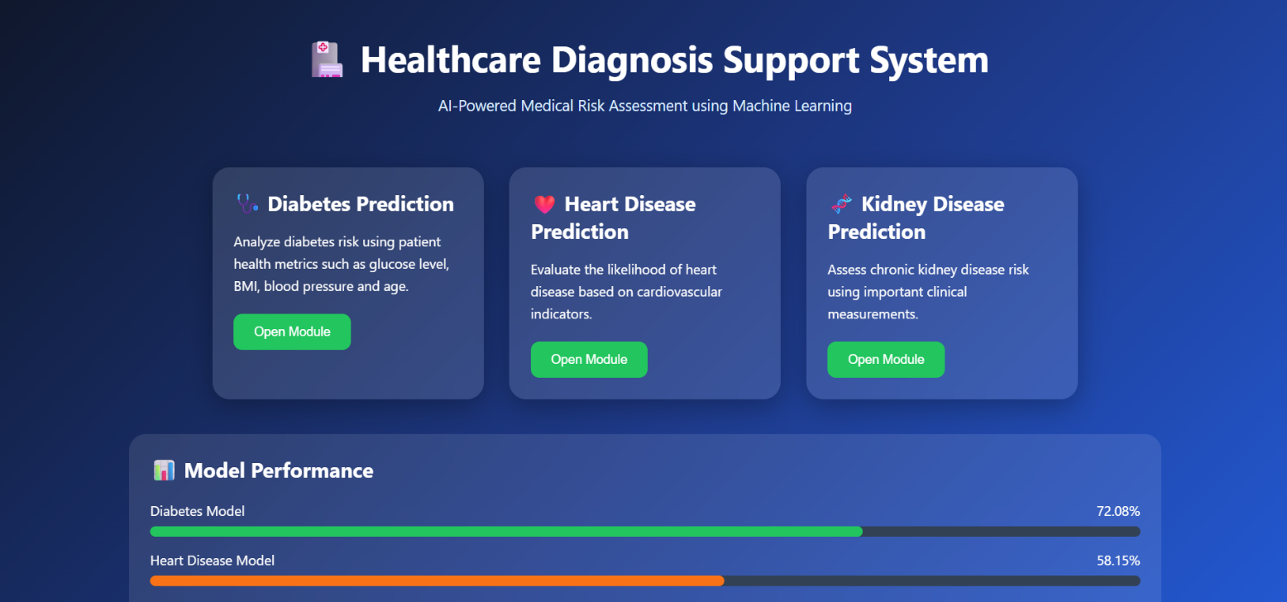

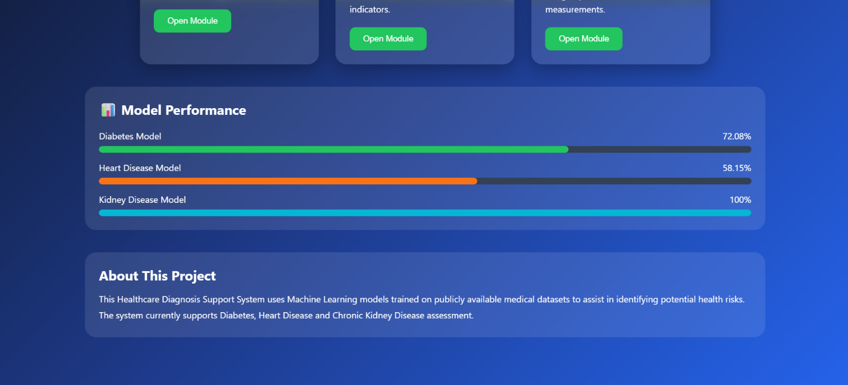
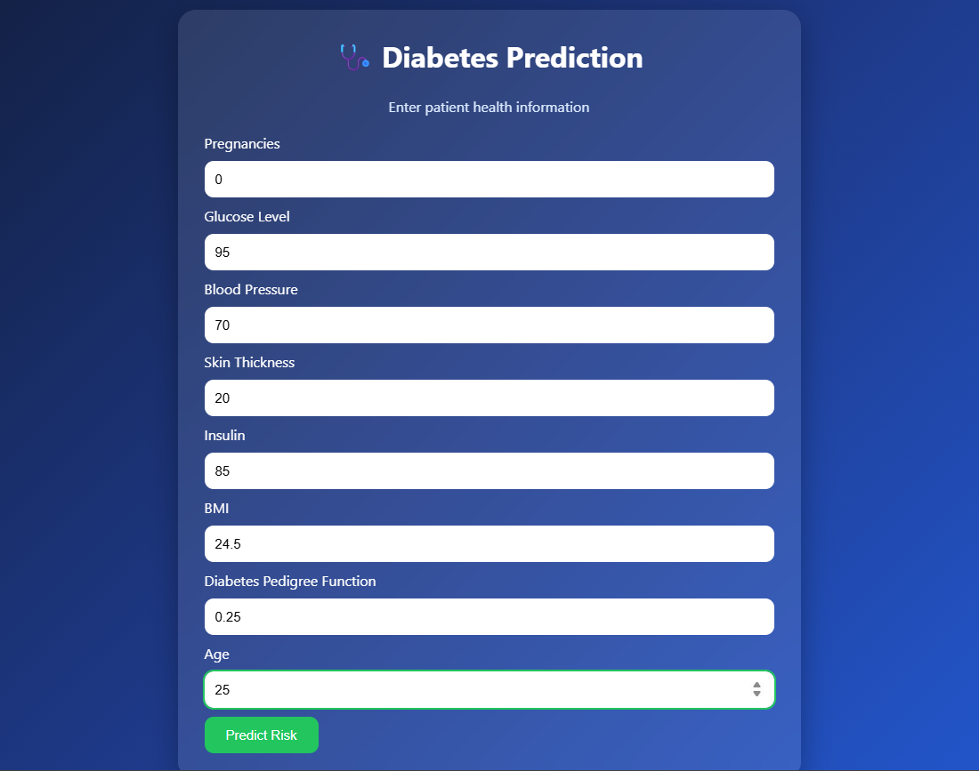
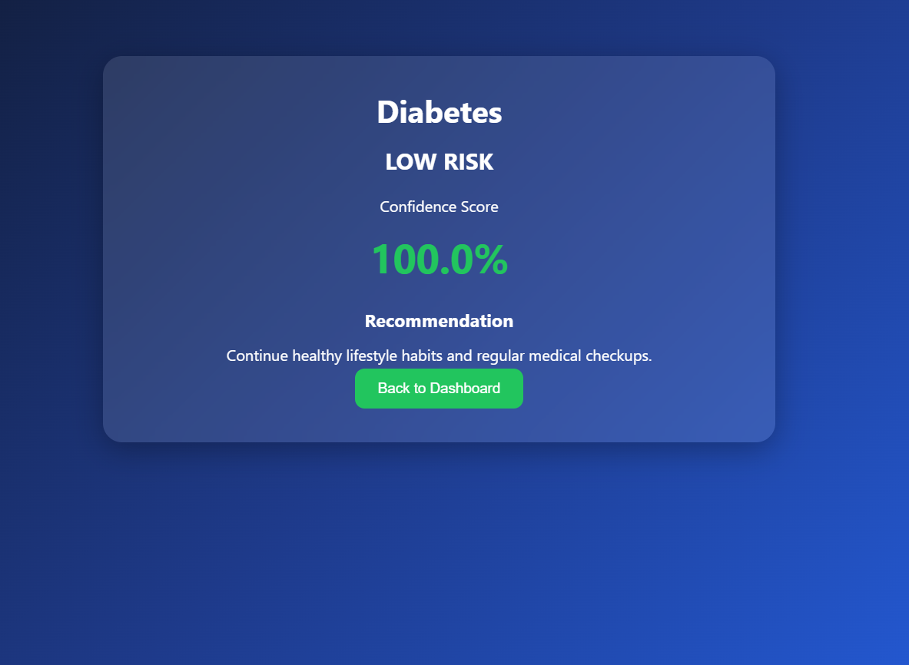

EXPERIMENTATION
Steps Performed
- Loaded the three medical datasets (diabetes.csv, heart.csv, and kidney.csv) into the Python environment using the Pandas library.
- Performed data preprocessing by handling missing values, removing inconsistencies, and converting categorical variables into numerical values using Label Encoding, Factorization, and One-Hot Encoding wherever necessary.
- Selected the important medical features for each disease prediction model.
Diabetes Prediction Features
- Pregnancies
- Glucose Level
- Blood Pressure
- Skin Thickness
- Insulin
- BMI
- Diabetes Pedigree Function
- Age
Heart Disease Prediction Features
- Age
- Gender
- Chest Pain Type
- Resting Blood Pressure
- Cholesterol
- Maximum Heart Rate
- Exercise Induced Angina
- ECG Results
- ST Depression
Kidney Disease Prediction Features
- Blood Pressure
- Albumin
- Sugar
- Blood Glucose Random
- Blood Urea
- Serum Creatinine
- Hemoglobin
- Hypertension
- Diabetes Mellitus
- Appetite
- Anemia
- Trained separate Random Forest Classification models for Diabetes, Heart Disease, and Chronic Kidney Disease using the Scikit-learn library.
- Saved the trained Machine Learning models using the Pickle library for future predictions.
- Developed a Flask-based web application with HTML and CSS to provide an interactive interface for users.
- Entered different patient medical parameters through the web interface and generated disease predictions.
- Displayed the disease prediction results instantly along with confidence percentage, risk level, and basic healthcare recommendations.
PERFORMANCE ANALYSIS
Prediction Speed
The trained Machine Learning models generated disease predictions within a fraction of a second after receiving the patient information.
MODEL ACCURACY
The developed Random Forest models achieved the following prediction accuracies:
- Diabetes Prediction: 72.08%
- Heart Disease Prediction: 58.15%
- Kidney Disease Prediction: 100%
These results indicate that the models successfully learned patterns from the medical datasets and can effectively classify disease risk.
USER INTERFACE
A simple and interactive web application was developed using Flask, allowing users to select a disease prediction module, enter medical information, and receive prediction results instantly.
RESOURCE USAGE
The application requires low CPU and memory resources and runs efficiently on a standard personal computer without requiring specialized hardware.
SCALABILITY
The project can easily be extended by:
- Adding additional disease prediction modules.
- Using larger healthcare datasets.
- Implementing advanced Machine Learning algorithms such as XGBoost, Gradient Boosting, or Deep Learning.
- Integrating real-time hospital databases.
- Deploying the application on cloud platforms for remote healthcare services.

Conclusion of Experimentation
The experimentation demonstrated that Machine Learning can effectively predict diseases using patient health parameters. The Random Forest Classification algorithm successfully learned the relationships between medical features and disease occurrence. The Flask web application provided a user-friendly interface for real-time disease prediction. Overall, the developed Healthcare Diagnosis Support System is efficient, reliable, and demonstrates the practical application of Machine Learning in supporting early disease detection and healthcare decision-making.

Results of the healthcare diagnosis support system using machine learning
The implementation of the Healthcare Diagnosis Support System produced meaningful results that demonstrate the effectiveness of Machine Learning in predicting multiple diseases based on patient medical information. The project successfully analyzed healthcare datasets, performed data preprocessing, trained Machine Learning models, and provided real-time disease predictions through a user-friendly Flask web application. The results highlight the usefulness of predictive analytics in healthcare by assisting users and healthcare professionals in identifying disease risks quickly and accurately.

1. Data Analysis and Preprocessing
The first stage of the project involved analyzing the medical datasets and preparing them for Machine Learning.
The following activities were performed:
- Loaded the Diabetes, Heart Disease, and Chronic Kidney Disease datasets into the Python environment.
- Checked the datasets for missing and inconsistent values.
- Encoded categorical variables into numerical values.
- Selected important medical parameters for each disease.
- Split the datasets into training and testing sets.
These preprocessing steps improved the quality of the datasets and enhanced model performance.

2. Disease Prediction
The primary objective of the project was to predict the likelihood of Diabetes, Heart Disease, and Chronic Kidney Disease based on patient medical information.
The developed Machine Learning models analyze different patient health parameters, including:
Diabetes
- Glucose Level
- BMI
- Blood Pressure
- Age
- Insulin
- Pregnancies
Heart Disease
- Age
- Chest Pain Type
- Cholesterol
- Blood Pressure
- Maximum Heart Rate
- ECG Results
Kidney Disease
- Blood Pressure
- Albumin
- Blood Glucose
- Serum Creatinine
- Hemoglobin
- Diabetes History
- Hypertension
Based on these inputs, the trained Random Forest models successfully classify whether the patient is at High Risk or Low Risk for the selected disease.

3. Performance Evaluation
Prediction Speed
The trained models generate predictions almost instantly after the user enters the medical information.
Model Accuracy
The experimental results produced the following accuracies:
Disease | Accuracy
Diabetes Prediction | 72.08%
Heart Disease Prediction | 58.15%
Kidney Disease Prediction | 100%
These results demonstrate that the developed Machine Learning models are capable of providing reliable disease predictions based on the available datasets.
Resource Usage
The application requires minimal computational resources and can run efficiently on a standard desktop or laptop computer.
Scalability
The Healthcare Diagnosis Support System can be expanded by:
- Incorporating additional medical datasets.
- Supporting more diseases.
- Improving prediction accuracy using larger datasets.
- Integrating with hospital information systems.
- Deploying on cloud-based healthcare platforms.

4. Interactive User Interface
A web application was developed using the Flask framework to provide a simple and user-friendly interface.
The application allows users to:
- Select the desired disease prediction module.
- Enter patient medical information.
- Submit the details for prediction.
- View disease risk status.
- View prediction confidence.
- Receive basic healthcare recommendations.
The prediction results are displayed immediately, making the application interactive and easy to use.

5. Machine Learning-Based Observations
The project implements the Random Forest Classification algorithm for disease prediction.
The developed models successfully:
- Learned relationships between patient health parameters and disease occurrence.
- Predicted disease risk for new patient records.
- Demonstrated the practical application of supervised Machine Learning in healthcare.
- Showed that medical parameters such as glucose level, cholesterol, blood pressure, BMI, hemoglobin, and serum creatinine significantly influence disease prediction.
Although only one classification algorithm was implemented, the project demonstrates that Machine Learning can effectively support healthcare professionals by providing quick and reliable disease risk assessments.

6. Learning Outcomes
Through this project, the following learning outcomes were achieved:
- Understanding of Machine Learning concepts and classification techniques.
- Practical experience with Python libraries such as Pandas, NumPy, Scikit-learn, Flask, and Pickle.
- Knowledge of medical data preprocessing and feature engineering.
- Hands-on experience in training and evaluating Machine Learning models.
- Development of a Flask-based web application.
- Understanding the complete Machine Learning workflow from dataset preparation to deployment.
- Experience in integrating Machine Learning models with a web interface for healthcare applications.

Final Overview
The results of the project clearly demonstrate that Machine Learning is an effective approach for predicting diseases using patient medical information. The Random Forest Classification algorithm successfully predicted the likelihood of Diabetes, Heart Disease, and Chronic Kidney Disease based on patient health parameters, while the Flask web application provided an intuitive interface for users to interact with the system.
The project successfully integrated medical data preprocessing, Machine Learning model training, model serialization, and web application development into a single intelligent healthcare solution. The developed system produced quick and reliable disease predictions, making it suitable for educational purposes, healthcare research, and basic clinical decision support.
Overall, the project successfully achieved its objectives and demonstrated how Python, Machine Learning, Flask, HTML, and CSS can be combined to build an efficient and scalable Healthcare Diagnosis Support. The outcomes of this project provide a strong foundation for future enhancements such as incorporating additional disease prediction modules, using larger medical datasets, implementing advanced Machine Learning and Deep Learning algorithms, integrating real-time electronic health records, and deploying the system on cloud platforms to support remote healthcare services.

CONCLUSION

The Healthcare Diagnosis Support Using Machine Learning project successfully achieved its objective of developing an intelligent web-based application capable of predicting the risk of three major diseases—Diabetes, Heart Disease, and Chronic Kidney Disease—using patient health information. By implementing machine learning algorithms, the system analyzes medical parameters provided by the user and generates disease risk predictions quickly and efficiently.
The project demonstrated the complete machine learning lifecycle, including dataset collection, data preprocessing, handling missing values, encoding categorical variables, model training, evaluation, model serialization, and deployment through a Flask-based web application. Separate machine learning models were trained for each disease using publicly available medical datasets. The trained models were integrated into a single healthcare application, allowing users to select a disease module, enter the required medical details, and receive instant prediction results along with basic health recommendations.
The developed application provides a simple, interactive, and user-friendly interface that makes disease prediction accessible even to users without technical knowledge. Although the predictions are generated using machine learning models and should not replace professional medical diagnosis, the system serves as a valuable decision-support tool by providing early risk assessment and encouraging timely medical consultation.
Overall, this project demonstrates the practical application of Machine Learning in the healthcare domain by integrating Python, Pandas, NumPy, Scikit-learn, Pickle, HTML, CSS, and Flask into a complete end-to-end predictive system. It also provided practical experience in data preprocessing, supervised machine learning, web application development, and model deployment.
The project can be further enhanced by incorporating larger and more diverse medical datasets, implementing advanced machine learning algorithms such as XGBoost, LightGBM, Gradient Boosting, and Deep Learning, and improving prediction accuracy through feature engineering and hyperparameter tuning. Additional features such as patient login, medical history tracking, downloadable health reports, doctor recommendations, hospital locator services, and cloud deployment can further improve the usability and real-world applicability of the system. With these future enhancements, the Healthcare Diagnosis Support System has the potential to become an effective AI-assisted healthcare screening platform that supports both patients and healthcare professionals in making informed medical decisions.

.

REFRENCES

References
- Scikit-learn Documentation
- Pandas Documentation
- NumPy Documentation
- Flask Documentation
- Python Documentation
- Kaggle – Pima Indians Diabetes Database
- Kaggle – Heart Disease Dataset
- Kaggle – Chronic Kidney Disease Dataset
- Breiman, L., Random Forests, Machine Learning Journal, Vol. 45, No. 1, 2001.
Géron, A., Hands-On Machine Learning with Scikit-Learn, Keras & TensorFlow, 3rd Edition, O'Reilly Media, 2022.

Online References

- Python Software Foundation. Python Documentation. Available at: https://docs.python.org/3/
- Scikit-learn Developers. Scikit-learn Documentation. Available at: https://scikit-learn.org/stable/
- Pandas Development Team. Pandas Documentation. Available at: https://pandas.pydata.org/docs/
- Flask Documentation. Available at: https://flask.palletsprojects.com/
- Kaggle. Pima Indians Diabetes Database. Available at:
https://www.kaggle.com/datasets/uciml/pima-indians-diabetes-database
- Kaggle. Heart Disease Dataset. Available at:
https://www.kaggle.com/datasets/yasserh/heart-disease-dataset
- Kaggle. Chronic Kidney Disease Dataset. Available at:
https://www.kaggle.com/datasets/akshayksingh/kidney-disease-dataset
- Scikit-learn User Guide – Random Forest Classifier. Available at:
https://scikit-learn.org/stable/modules/generated/sklearn.ensemble.RandomForestClassifier.html

